**DBMS PROJECT**

**ONLINE INVENTORY MANAGEMENT SYSTEM**

**Key Milestone 1**



## CSE403L Database Management System Lab

Group members

**Arsalan khan (22PWCSE2110)**

**Waseem (22PWCSE2179)**

**Adnan Zeb (22PWCSE2191)**

Class Section: **A**

“On my honor, as student of University of Engineering and Technology, I have neither given nor received unauthorized assistance on this academic work.”

Student Signature:

Submitted to:

## Engr.Sumayyea Salahuddin

(MAY 25, 2025)

Department of Computer Systems Engineering

University of Engineering and Technology, Peshawar

**ONLINE INVENTORY MANAGEMENT SYSTEM**

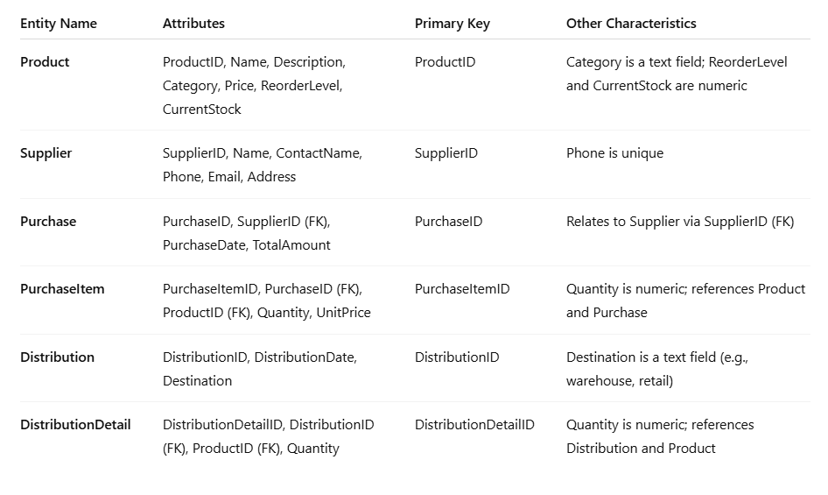**Entity Description Table**

**Detailed Business Rules**

1. Each Product belongs to exactly one Category (as a text attribute), and each Category can contain multiple Products.
2. Each Product can be supplied by one or more Suppliers.
3. A Supplier can supply multiple Products.
4. Each PurchaseOrder is placed with exactly one Supplier.
5. Each PurchaseOrder must contain one or more PurchaseOrderDetail entries, each linking a Product to the order, specifying the quantity and unit price.
6. PurchaseOrderDetail is a weak entity that depends on both PurchaseOrder and Product for its identification and existence.
7. StockMovement is used to track any changes in product stock, whether restocking or reductions (sales, adjustments, etc.).
8. The MovementType attribute in StockMovement can only have two valid values: "In" (to indicate stock addition) or "Out" (to indicate stock deduction).
9. A Product’s inventory level is dynamically calculated based on the sum of all related StockMovement records. “In” adds to inventory, while “Out” subtracts from it.
10. A Product cannot be distributed if its CurrentStock is less than the quantity requested in the DistributionDetail.
11. Each Distribution record must include at least one associated DistributionDetail.
12. Quantities in PurchaseItem and DistributionDetail must be positive numbers.
13. A Purchase must not be saved without at least one PurchaseItem linked to it.
14. When a PurchaseItem is added, the corresponding Product’s CurrentStock must be increased by the purchased quantity.
15. When a DistributionDetail is added, the Product’s CurrentStock must be decreased by the distributed quantity.
16. All foreign key references (e.g., SupplierID, ProductID) must correspond to existing entries in their respective parent tables.
17. Deletion of a Supplier or Product is not permitted if they are referenced in existing Purchase, PurchaseItem, or DistributionDetail records.

**Entity Relationship Diagram (ERD)**

1. **Product**

* ProductID (PK)
* Name
* Description
* Price
* ReorderLevel
* CurrentStock

1. **Supplier**

* SupplierID (PK)
* Name
* ContactName
* Phone
* Email
* Address

1. **Purchase**

* PurchaseID (PK)
* SupplierID (FK)
* PurchaseDate
* TotalAmount

1. **PurchaseItem**

* PurchaseItemID (PK)
* PurchaseID (FK)
* ProductID (FK)
* Quantity
* UnitPrice

1. **Distribution**

* DistributionID (PK)
* DistributionDate
* CustomerName
* Contact
* Address

1. **DistributionDetail**

* DistributionDetailID (PK)
* DistributionID (FK)
* ProductID (FK)
* Quantity

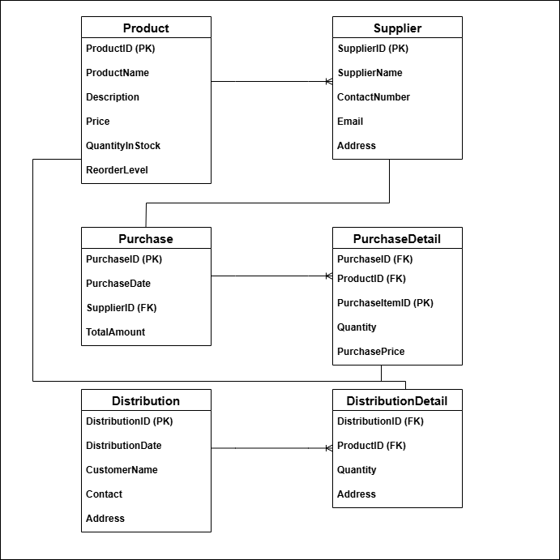

**Enhanced Entity Relationship Diagram (EERD)**

1. **Generalization/Specialization** (if needed, e.g., Supplier as LocalSupplier vs InternationalSupplier)
2. **Categories** (if products are of multiple types: e.g., Perishable vs Non-Perishable)
3. **Derived attributes** (e.g., Product’s TotalQuantityInStock can be derived from StockMovement)
4. **Participation constraints** (Total vs Partial, min-max cardinality)

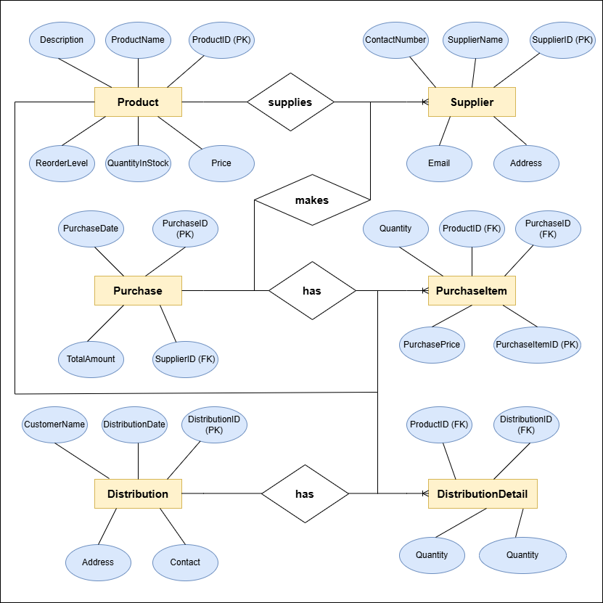

**References**

https://chatgpt.com/c/68332bf2-96a0-800e-a887-ace82ab513a5

https://chatgpt.com/c/68334e0d-b7dc-800e-ba3b-555c7904535c